Control-shift-C-"motherlode." It's a series of commands that every Sims player knows, the one that infuses your bank account with precious simoleans for buying the fanciest lamps, laying the plushest carpet, and landscaping with the most impressive of shrubbery. Few games are so defined by their cheat codes, yet if you want to move a digital family into an upscale abode without devoting dozens of hours to building up funds, this code is your ticket to affordable maid service and plush window treatments.
This approach treats The Sims as a dollhouse, a role that The Sims 4 fulfills with some aplomb. If you want to build but prefer not to micromanage the details, the game comes with various prearranged rooms that you can fit together like Tetris pieces, but if you're devoted to the arts of architecture and interior design, you have the series most streamlined set of buying and building tools yet. Buy and Build modes share the same interface, making it simple to mix creation and decoration rather than forcing you to approach each activity as an opposing side of the same simolean. Stretching and dragging walls into properly modular rectangles? It's as easy as knowing how to use a mouse and keyboard. Not sure what category a chess set falls under? Just type a keyword into the search field and select the best match. Given the conflation of two modes into one, and the amount of categories to sift through, The Sims 4 does a creditable job of leading you right to the objects and tools you're seeking.
On the surface, there would seem to be more than enough styles and objects from which to choose: sofas of various shapes and colors, tiles for making your bathroom as 1970s-era-tacky as you'd like, and other means of personalizing the homes of your little computer people. When the time comes to set up a life of leisure, however, the boundaries become more rigid than they first appear. The Sims 3's Create-a-Style options, which let you texturize and paint your surfaces and textiles in intricate ways, has been dropped, leaving only predetermined colors in their place. Color can make a great throughline for aesthetically linking various shapes and styles, but should you gun for an eclectic interior, you quickly find that objects don't always have the same hues available between them. Mixing and matching can make a room look more random than refined; the Create-a-Style option provided a means of connecting disparate decor, and its loss diminishes creativity.
In fact, The Sims 4 as a rule feels diminished when compared to even the vanilla version of The Sims 3, before it had the benefit of add-ons that let you be a ghostbuster and live in high-rises. Much has already been made of the features that didn't make the cut, but even if you don't have a list of those features on hand when you play, the squashed purview is apparent. I didn't mind the small lot I initially laid claim to until I decided to splurge on a telescope, an item that at one time was compact enough to fit into a small corner of the yard. By contrast, The Sims 4's starting telescope, a gargantuan beast that most amateur astronomers would kill to own, couldn't fit, and I ultimately erected it on a public lot, in front of the library. Previous Sims modders (and a Sims 2expansion) had introduced microscopes to the mix, but I had no room for the lab-quality colossus in The Sims 4. Limitations, limitations, limitations. It wasn't The Sims I had gotten used to over the last several years.
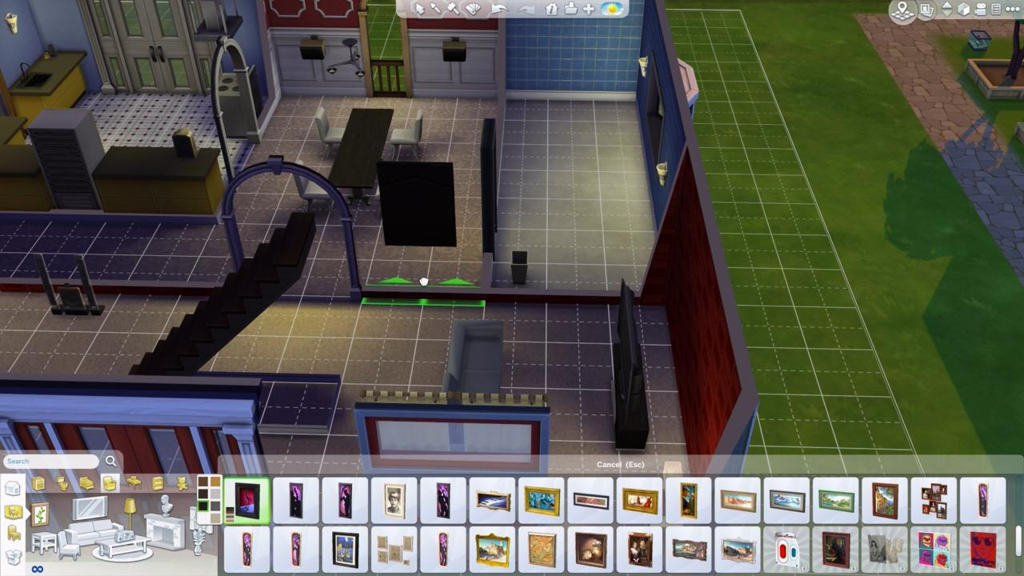Creating a nice home is simple--provided you don't want a basement.
The Sims 4 doesn't just take away. It has presents to give, too, in the form of new kinds of social interactions, objects, and other charming detours that make keeping an eye on your sims a sheer delight. Multitasking is at the forefront of these changes: sims greet visitors without putting down their cereal bowls and chat while gardening. Using the toilet is also not an event your sims have to fully focus on, and I laughed heartily when the digital version of myself sat on the john while playing games on his tablet; it really was like peeking in on a little me. My sim daughter, meanwhile, felt it was appropriate to drink her orange juice while peeing, a combination of activities I am not sure I can support.
I am not sure I should share my misgivings with the young woman, though. In The Sims 4, sims are quite moody, getting embarrassed should you send one sim to the shower when another is seated on the toilet, and getting randy when they're in the vicinity of their spouses. You're constantly pushed to take advantage of these moods, earning points for small accomplishments that you spend on rewards that provide temporary buffs (get energized immediately!) or permanent enhancements (never get fired!). Sims also gain access to new kinds of social interactions when they get moody--angry sims want to get in fights, embarrassed sims need reassurance, focused sims want to play chess, and so forth.
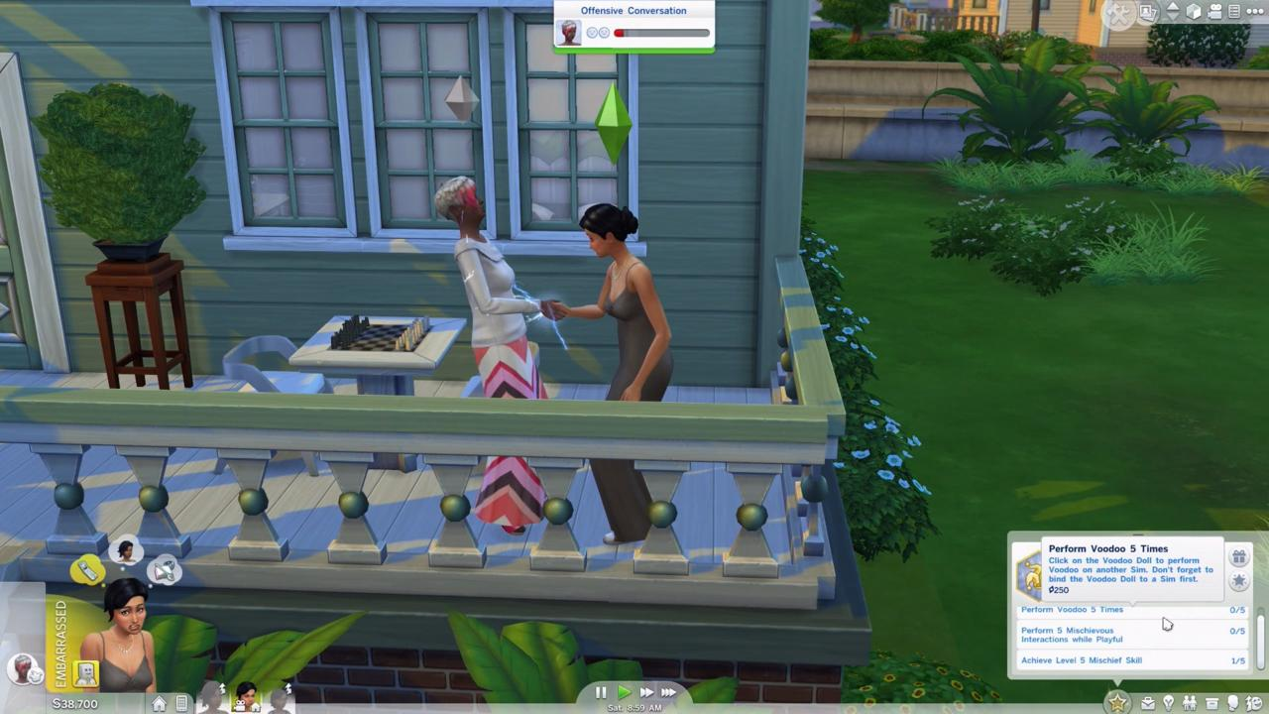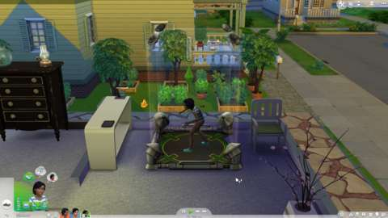Hand buzzers and holographic video games: Entertainment at its best!
Changes in mood are accompanied by predictably ridiculous exclamations in the gibberish language known as simlish. One sim I closely maintained was particularly mischievous, fooling neighbors with a hand buzzer and insulting anyone that dared assemble at the club while she sucked down a nightcap. I would have her make fun of other sims' clothing, which she did in an adorable snotty tone, causing her victim to recoil in horror at her obnoxiousness. I gave that same sim the snobby trait, and selected a default walk animation which had her head tilted upwards so that she could look down her nose at the plebeians that dared walk the same Earth. Watching her strut her stuff was consistently wonderful, though she wasn't the only digital person worth keeping an eye on: miniature me would use books as puppets, opening and closing them like mouths and mimicking what they might say before cracking them open and actually reading. Watching your sims in action means having a frequent smile stretched across your face.
Turning these individual activities into long-form stories isn't as compelling as it was in The Sims 3, however. The previous game's open world, which allowed for seamless travel and smooth multi-sim control, has been replaced by smaller lots separated by loading screens--a system that harks back to older games in the series. Having to stare at a loading screen when you want to travel to the park is distracting enough; moving back to your home lot to maintain other family members and finding them standing stiffly in front of the house, waiting for your commands rather than naturally going about their business, is even more so.
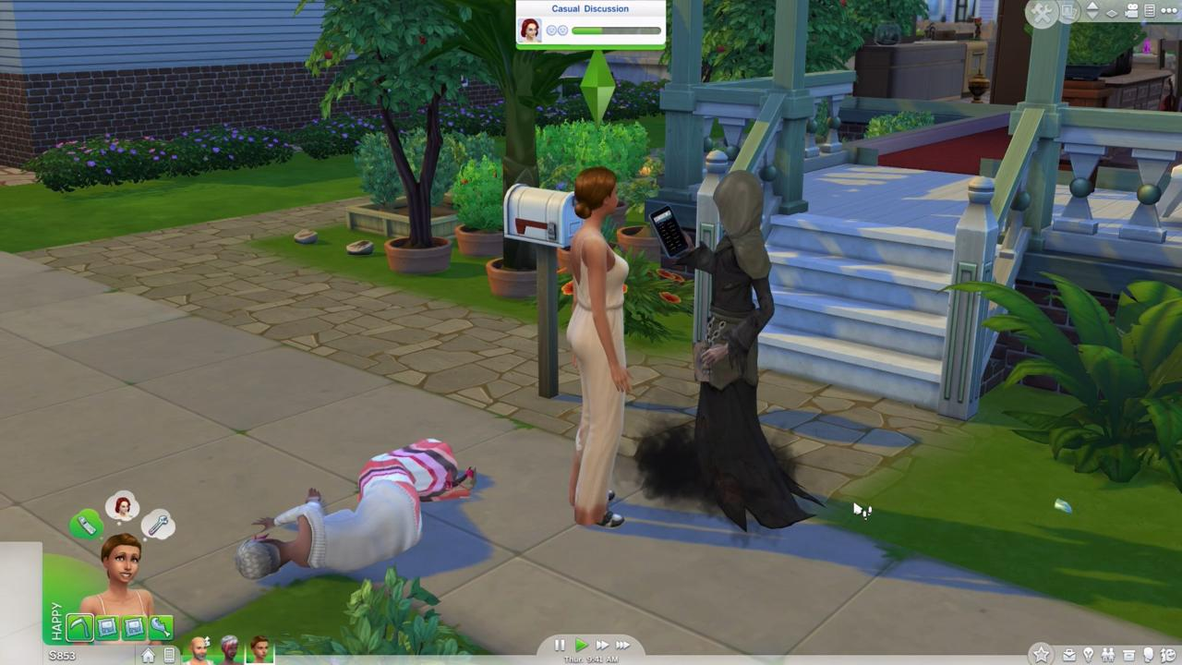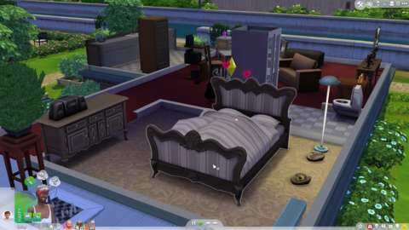Death and woohoo. The circle of Sims life.
The deeper you wish to go, the more roadblocks you stumble upon. Perhaps it's sensible that a game with no large spaces to traverse would not feature bicycles, but I still miss riding across town, zooming over hills and through valleys until I reached the graveyard and harassed the ghosts there. Not only is transportation gone, but so are the hills and valleys, all of them smoothed out into a uniformly flat surface that doesn't support basements or terraforming. Elsewhere, the emphasis on specific tasks detracts from the freeform noodling. When giving my first birthday party, for instance, I was so focused on fulfilling assigned tasks like serving drinks that I failed to notice how differently The Sims 4 handled birthday cakes than its predecessor. I missed being able to simply buy the cake, scatter around some balloons, and have a wonderful time. When I had failed to please the birthday girl, I didn't feel as though I hadn't given everyone a good enough time--I felt like I hadn't clicked on the right things in the right order. It is in that distinction that you find the difference between The Sims 4 and its predecessor.
In short, The Sims 4's biggest problem is that The Sims 3 exists, and describing where it stumbles by necessity means looking at where the series has been. This is a lovely and lively game that elicits constant smirks, but The Sims 4's moments never feel like part of a bigger picture. Spontaneity is limited in turn, which brings me back to that gargantuan telescope now sitting in front of the library. Gazing at the stars means enduring a loading screen, and while I appreciate the top-level commands that I can issue to family members playing in other lots, simultaneously spending time with other sims means enduring even more loading screens, or forcing my family to travel together. I love looking at and listening to The Sims 4, but those little digital people aren't so enchanting as to keep me hooked--not when a decked-out version of The Sims 3 is far more inviting.
Formun Üstü


The Sims 4 / PC
THE GOOD
Colorful visuals and fantastic audio make watching your sims a joy
The core build and buy tools are both robust and accessible
Moods and multitasking lead to hilarious sim actions
THE BAD
Cramped structure limits personal stories and restrains multi-sim control
Far too many series features have been frustratingly pruned or removed
6
FAIR
About GameSpot's Reviews

